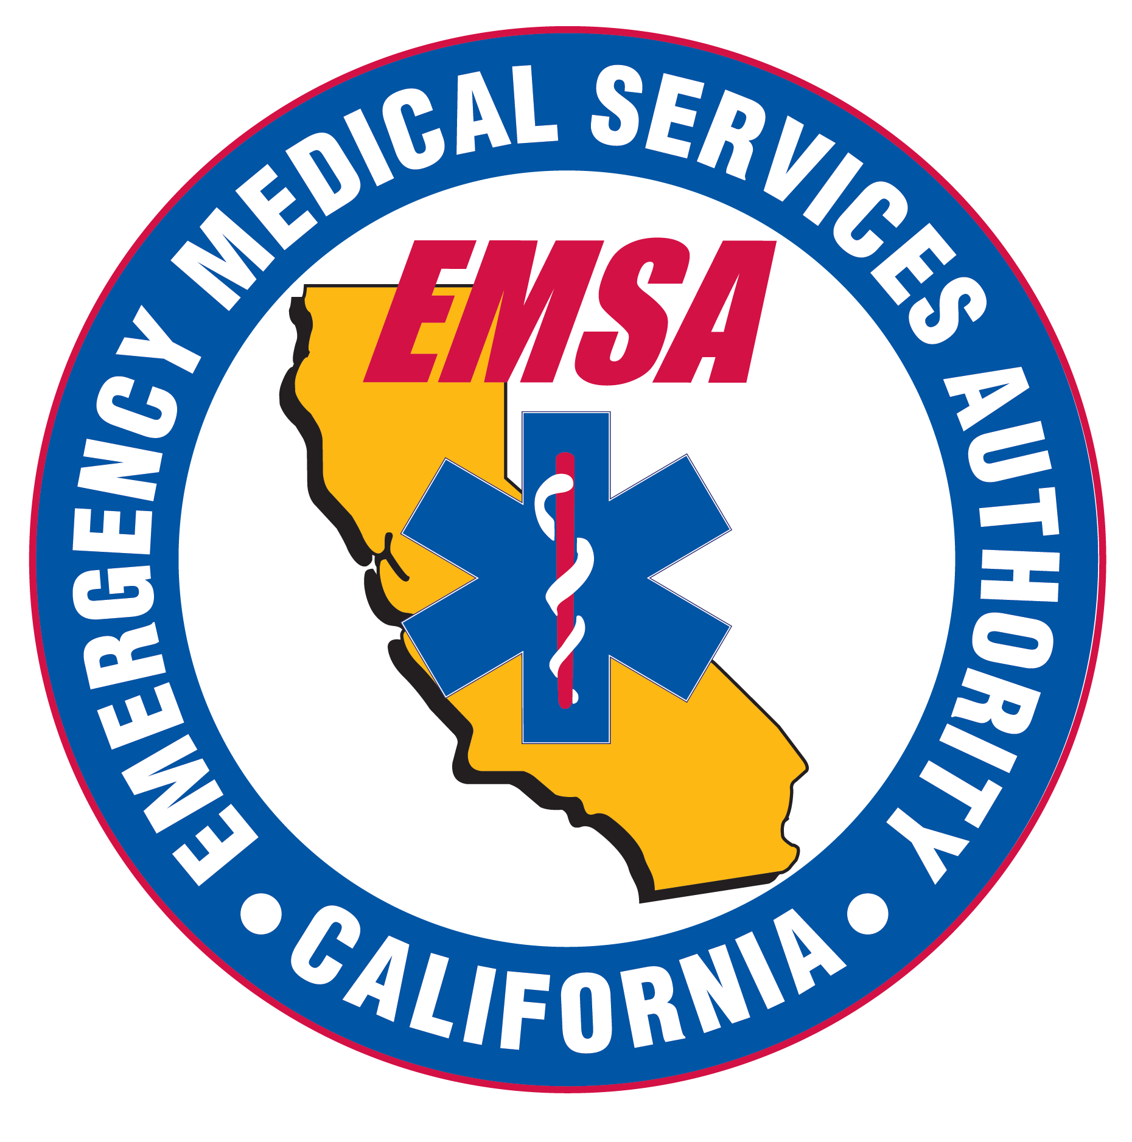
STATE USE ONLY

Lic./Cert. ________________

CPR/AED:_______________

Fee:____________________

Processed by:_______________

Date:______________________

CALIFORNIA EMS AUTHORITY
Epinephrine Auto-Injector Program
10901 Gold Center Drive, Ste. 400, Rancho Cordova, CA 95670-6073
TELEPHONE (916) 323-9875 / FAX (916) 324-2875

STATE OF CALIFORNIA
EPINEPHRINE CERTIFICATION APPLICATION

Please Type or Print Clearly. The non-refundable fee of $15.00 may be paid by check or money order
made payable to the Specialized First Aid Fund.

PERSONAL INFORMATION
Last Name: |  | First Name: |  |  |  | Middle Initial:
Residential Address: |  | City: |  |  | State: | Zip Code:
Date of Birth (mm/dd/yyyy): | Social Security Number:
 | - -
Home Phone Number: | Cell Phone Number: |  |  | Email Address:
( ) - | ( ) -
CERTIFICATION ELIGIBILITY
(Attach copy of License, Certification, or Epinephrine Auto-Injector Course Completion)
Type of Healthcare License/Certification (if applicable): |  |  | License/Certification # (If applicable):
Epinephrine Auto-Injector Course Provider Name (if applicable): |  |  | Course Completion Date (if applicable):
CPR/AED Certification Date:
SIGNATURE
I hereby certify under penalty of perjury that all information on this application is true and correct to the best of my knowledge and belief, and I understand that any falsification or omission of material facts may cause forfeiture on my part of all rights to Epinephrine certification in the State of California. I understand all information on this application is subject to verification, and I hereby give my express permission for the EMS Authority to contact any person or agency for information related to my role and function as an Epinephrine Auto-Injector certified person in California.
SIGNATURE OF APPLICANT DATE

CONTINUE NEXT PAGE (INSTRUCTIONS)

Epinephrine Certification Application

INSTRUCTIONS
Complete the Epinephrine Certification Application. Do not leave any section blank. Incomplete applications will be returned.
Sign and date the application. Only original signatures are accepted.
Attach a copy of your current healthcare license, healthcare certification, or a copy of your Epinephrine Auto-Injector course completion document.
Attach a copy of your current CPR/AED Certification
Include payment in the amount of $15.00 (application fee) with your application.
This non-refundable fee may be check, or money order made payable to the
Specialized First Aid Fund. Do not mail cash or pay via email.

Send your application, payment, and the required documents (if not emailed) noted above to the following address:
Emergency Medical Services Authority
Licensure Unit
10901 Gold Center Drive, Suite 400
Rancho Cordova, CA 95670

CERTIFICATION ELIGIBILITY

- Currently licensed or certified California physician assistants, registered nurses, nurse practitioners, nurse midwives, clinical nurse specialists, nurse anesthetists, mobile intensive care nurse, paramedics and advanced emergency medical technicians (AEMTs) are deemed to have met the requirement for training and are eligible to apply for certification.

- California emergency medical technicians (EMTs), lifeguards, firefighters and peace officers who have successfully completed training in the administration of epinephrine by auto-injector, approved by a local EMS agency or the EMS Authority, are eligible to apply for certification.

- Individuals who have a course completion document from an EMSA approved epinephrine auto-injector training program signed by the class instructor are eligible to apply for certification.

For additional information:

- Send your inquiries to the Emergency Medical Services Authority at epi_cert@emsa.ca.gov or

- Contact us by phone at (916) 323-9875.

