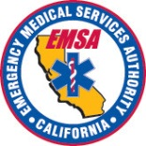
SALT TRIAGE

Sort, Assess, Lifesaving Interventions, Treat/Transport

