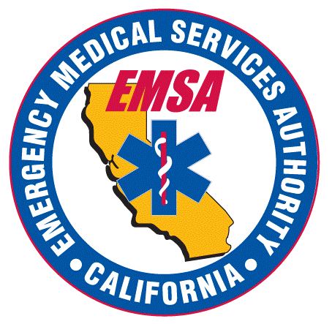
Emergency Medical Authority Services
Paramedic Disciplinary Review Board
July 13, 2023
3:00 P.M. – 4:00 P.M.

Location:
Microsoft Teams Meeting
Click here to join the meeting
Meeting ID: 284 864 957 88
Passcode: tRgFgj

Or call in (audio only)
+1 916-720-2015,,432271869# United States, Sacramento
Phone Conference ID: 432 271 869#

Agenda

3:00 p.m. OPEN SESSION

- Call to Order/Introductions and Roll Call/Establishment of a Quorum

- Election of Board Chairperson (Health and Safety Code section 1795.125.03)

3:20 p.m. CLOSED SESSION*

- Deliberation on disciplinary matters, including proposed decisions (Government Code section 11126(c)(3))

3:50 p.m. OPEN SESSION

- Adjournment

* The Board will convene in Closed Session, as authorized by Government Code section 11126(c)(3), to deliberate on proposed disciplinary decisions and, if applicable, stipulations. For additional information, please contact pdrb@emsa.ca.gov.
Government Code section 11125.7 provides the opportunity for the public to address each agenda item during discussion or consideration by the Board prior to the board taking any action on said item. Members of the public will be provided appropriate opportunities to comment on any issue before the Board, but the Board Chairperson may, at their discretion, apportion available time among those who wish to speak. Individuals may appear before the Board to discuss items not on the agenda; however, the Board can neither discuss nor take official action on these items at the time of the same meeting. (Government Code section 11125, 11125.7(a).) Government Code section 11125.7 does not apply to closed sessions held pursuant to section 11126. (Government Code section 11125.7(e)(1).)

This agenda can be found on the California Emergency Medical Services Authority’s website at emsa.ca.gov. The time and order of agenda items are subject to change at the discretion of the Board Chairperson and may be taken out of order. In accordance with the Bagley-Keen Open Meeting Act, all meetings of the Board are open to the public.

A full agenda packet will not be provided at the meeting; however, you can print a full packet, including the agenda from the Department’s website at www.emsa.ca.gov.

The meeting will be webcast, provided there are not unforeseen technical difficulties or limitations. To view the webcast, please visit www.emsa.ca.gov. The meeting will not be cancelled if webcast is not available. Meeting adjournment may not be webcast if it is the only item that occurs after a closed session.

The meeting is accessible to the physically disabled. Individuals with disabilities requiring auxiliary aids or services to ensure accessibility such as language interpreting, assisted listening device, materials in alternate formats or other accommodation, should contact pdrb@emsa.ca.gov no less than 7 days prior to the meeting.

